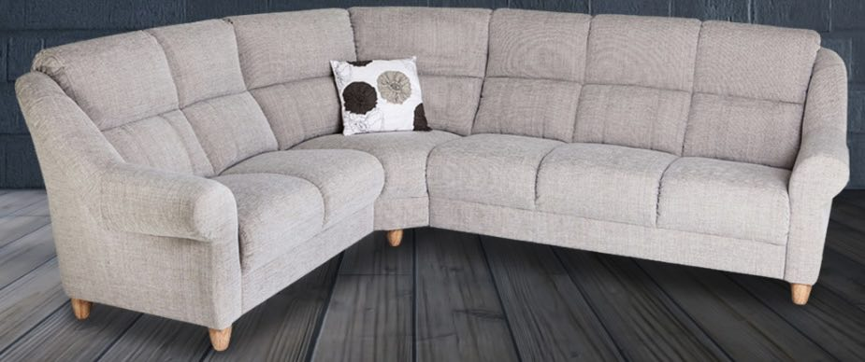 Mynta Soffa 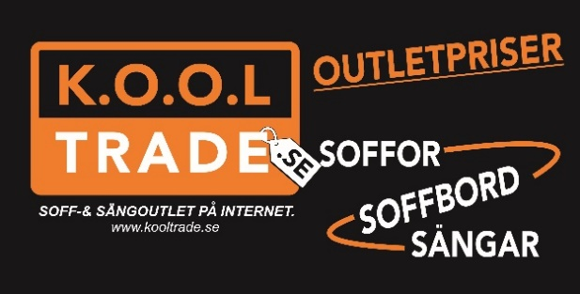
Size | High | Deep | Seat high | Seat deep | Wideness seat cushion | Pris

Mynta
2C3 | 228 cm x 278 cm | 98 cm | 92 cm | 45 cm | 51 cm | 50 cm | 16 995:-
3C3 | 278 cm x 278 cm | 98 cm | 92 cm | 45 cm | 51 cm | 50 cm | 18 995:-
2C2 | 228 cm x 228 cm | 98 cm | 92 cm | 45 cm | 51 cm | 50 cm | 15 995:-
3C1 | 278 cm x 178 cm | 98 cm | 92 cm | 45 cm | 51 cm | 50 cm | 15 995:-
2C1 | 228 cm x 178 cm | 98 cm | 92 cm | 45 cm | 51 cm | 50 cm | 14 995:-
3A | 194 cm | 98 cm | 92 cm | 45 cm | 51 cm | 50 cm | 9995:-
2A | 144 cm | 98 cm | 92 cm | 45 cm | 51 cm | 50 cm | 8995:-
1A | 99 cm | 98 cm | 92 cm | 45 cm | 51 cm | 55 cm | 6995:-
Tel : 070-2511722, Kooltrade Östersund, www.kooloutlet.se

