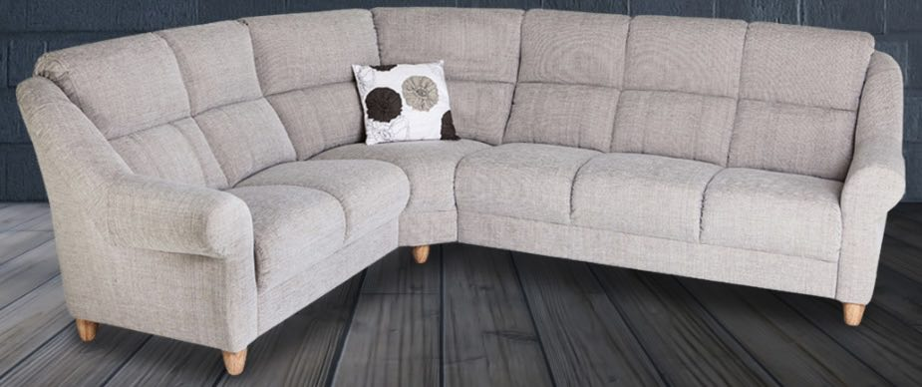 **Mynta Soffa** 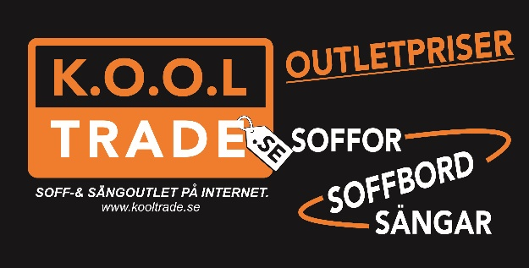

|  |  |  |  |  |  |  |
| --- | --- | --- | --- | --- | --- | --- |
| **Size** | **High** | **Deep** | **Seat high** | **Seat deep** | **Wideness seat cushion** | **Pris** |

|  |  |  |  |  |  |  |  |
| --- | --- | --- | --- | --- | --- | --- | --- |
| **Mynta** |  |  |  |  |  |  |  |
| 2C3 | 228 cm x 278 cm | 98 cm | 92 cm | 45 cm | 51 cm | 50 cm | **12 995:-** |
| 3C3 | 278 cm x 278 cm | 98 cm | 92 cm | 45 cm | 51 cm | 50 cm | **14 995:-** |
| 2C2 | 228 cm x 228 cm | 98 cm | 92 cm | 45 cm | 51 cm | 50 cm | **11 995:-** |
| 3C1 | 278 cm x 178 cm | 98 cm | 92 cm | 45 cm | 51 cm | 50 cm | **11 995:-** |
| 2C1 | 228 cm x 178 cm | 98 cm | 92 cm | 45 cm | 51 cm | 50 cm | **10995:-** |
| 3A | 194 cm | 98 cm | 92 cm | 45 cm | 51 cm | 50 cm | **8995:-** |
| 2A | 144 cm | 98 cm | 92 cm | 45 cm | 51 cm | 50 cm | **7995:-** |
| 1A | 99 cm | 98 cm | 92 cm | 45 cm | 51 cm | 55 cm | **5995:-** |

**Tel : 070-2511722, Kooltrade Östersund, www.kooloutlet.se**